Diketaui model
$$L\frac{dl}{dt}+RL=E(t)$$
misal t = 0, maka arus I = 0 A
- Jika $E\left(t\right)=E_{0}e^{-4t},$ tentukan solusi umum PD
- Jika R = 10, L = 2, dan E0=40, maka PD:
$$2\frac{dI}{dt}+10I=40e^{-4t}$$
$$\frac{dI}{dt}+5I=20e^{-4t}$$
$$\frac{dI}{dt}=20e^{-4t}-5I$$

- Solusi umum & khusus
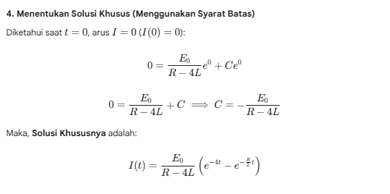
- Jika R = 10, L = 2, dan E0=40, maka solusi:
$$I\left(t\right)=20\left(e^{-4t}-e^{-5t}\right)$$
- Cari y eksak pakai metode analitik (excel) $∆t$=0,1
- Pakai metode prediktor korektor
Diketaui $f\left(t,I\right)=\frac{dI}{dt}=20e^{-4t}-5I$ dimana I(t=0)=0 A, h= $∆t$=0,1, maka
Prediktor: $I_{n+1}^{*}=I_{n}+hf\left(t,I\right)=I_{n}+0,1\left(20e^{-4t_{n}}-5I_{n}\right)$
Korektor: $I_{n+1}=I_{n}+\frac{h}{2}[f\left(t_{n},I_{n}\right)+f\left(t_{n+1},I_{n+1}^{*}\right)=I_{n}+0,05\left((20e^{-4t_{n}}-5I_{n}\right)+\left(20e^{-4t_{n+1}}-5I_{n+1 }^{*}\right)$
Manual:
Dimulai dari n=0, $t_{0}=0, I_{0}=0$, $t_{n+1}=t_{n}+h$
Prediktor: $I_{n+1}^{*}=I_{0}+hf\left(t_{0},I_{0}\right)=I_{0}+0,1\left(20e^{-4t_{0}}-5I_{0}\right)=0+0,1\left(20\right)=2$, $I_{1}^{*}=2$
Korektor: $I_{n+1}=I_{n}+\frac{h}{2}\left[f\left(t_{n},I_{n}\right)+f\left(t_{n+1},I_{n+1}^{*}\right)=I_{n}+0,05\left((20e^{-4t_{n}}-5I_{n}\right)+\left(20e^{-4t_{n+1}}-5I_{n+1 }^{*}\right)\right)$
$$I_{1}=I_{0}+0,05\left[f\left(t_{0},I_{0}\right)+f\left(t_{1},I_{1}^{*}\right)=I_{0}+0,05\left((20e^{-4t_{0}}-5I_{0}\right)+\left(20e^{-4t_{1}}-5I_{1 }^{*}\right)\right)$$
$$I_{1}=I_{0}+0,05\left((20e^{-4t_{0}}-5I_{0}\right)+\left(20e^{-4t_{1}}-5I_{1 }^{*}\right)=0+0,05\left(20+3,406\right)=1,1703$$
Dilanjutkan seterusnya hingga $n∈Z^{+}$
Persamaan yg dipakai di excel:
Prediktor: $I_{n+1}^{*}=I_{n}+0,1\left(20e^{-4t_{n}}-5I_{n}\right)$
Korektor: $I_{n+1}=I_{n}+0,05\left((20e^{-4t_{n}}-5I_{n}\right)+\left(20e^{-4t_{n+1}}-5I_{n+1 }^{*}\right)$

